POSITIVE AND NEGATIVE ASSOCIATION RULE MINING USING CORRELATION THRESHOLD AND DUAL CONFIDENCE APPROACH
B.TECH PROJECT REPORT



DEPARTMENT OF
COMPUTER SCIENCE AND ENGINEERING
NATIONAL INSTITUTE OF TECHNOLOGY, MIZORAM
(An Institution of National Importance under Ministry of HRD, Govt. of India)
Chaltlang, Aizawl – 796012, Mizoram
Tel/Fax: 0389-2341236(O)/ 0389-2341774 / 0389-2341699

PROJECT REPORT
ON
POSITIVE AND NEGATIVE ASSOCIATION RULE MINING USING CORRELATION THRESHOLD AND DUAL CONFIDENCE APPROACH
Submitted in partial fulfilment of the requirements for the award of the degree of
BACHELOR OF TECHNOLOGY
In
COMPUTER SCIENCE AND ENGINEERING
By
ANIMESH PAUL
(BT11CS003)

Department of Computer Science and Engineering
NATIONAL INSTITUTE OF TECHNOLOGY, MIZORAM
(An Institution of National Importance under Ministry of HRD, Govt. of India)
Chaltlang, Aizawl – 796012, Mizoram
Tel/Fax: 0389-2341236(O)/ 0389-2341774 / 0389-2341699
DECLARATION

I hereby declare that Project entitled “POSITIVE AND NEGATIVE ASSOCIATION RULE MINING USING CORRELATION THRESHOLD AND DUAL CONFIDENCE APPROACH” is bonafide work duly completed by me. It does not contain any part of the project or thesis submitted by any other candidate to this or any other institute of any university. All such materials that have been obtained from other sources have been duly acknowledged.
I declare that this written submission represents my ideas in my own words and where others' ideas or words have been included, I have adequately cited and referenced the original sources. I also declare that I have adhered to all principles of academic honesty and integrity and have not misrepresented or fabricated or falsified any idea/data/fact/source in my submission. I understand that any violation of the above will be cause for disciplinary action by the Institute and can also evoke penal action from the sources which have thus not been properly cited or from whom proper permission has not been taken when needed.

Date: 14th May 2015 ANIMESH PAUL
Place: Aizawl (BT11CS003)

DEDICATION

I dedicate this dissertation work to my family for nurturing me with affection and love and their dedicated partnership towards my success in life.
CERTIFICATE
This is to certify that the Thesis work titled “POSITIVE AND NEGATIVE ASSOCIATION RULE MINING USING CORRELATION THRESHOLD AND DUAL CONFIDENCE APPROACH” submitted by Mr. ANIMESH PAUL bearing enrolment number BT11CS003 in partial fulfilment of the requirements for the award of the degree of Bachelor of Technology in Computer Science and Engineering at
NATIONAL INSTITUTE OF TECHNOLOGY, MIZORAM is a record of bonafide work carried out by him.
The results embodied in this project report have not been submitted in any university or institute for the award of any degree and the results have been achieved satisfactorily.

Mr. Sandeep Kumar Dash Dr. Partha Pakray
(Asst. Professor & Project Guide) (Asst. Professor & HOD)
Dept. of CSE, NIT Mizoram Dept. of CSE, NIT Mizoram

Mr. Arunangshu Pal (External Examiner)
(Asst. Professor & Project Guide)
Dept. of CSE, NIT Mizoram
ABSTRACT

Mining of association rules has become an important area in the research of data mining. Association rule mining is an important technique to discover hidden relationships among items in the transaction. The key strength of association rule mining is that all interesting rules are found. Apriori algorithm is implemented using K-way join approach for support counting. Association is the discovery of frequent patterns and correlation relationships among huge amounts of data. Association rule mining consists of first finding frequent itemsets from which strong association rules in the form of A=>B are generated. These frequent patterns are used in classification, cluster analysis, and other data mining tasks. Area of applications is selective marketing, decision analysis and business management.

However, the traditional approaches bases on support-confidence framework may cause to generate a great number of redundant and contradictory association rules. For instance, the rules of the form A=>B and A=>¬B may be mined together, but the two rules are contradictory. In order to solve the problems, a correlation measure is defined and added to the mining algorithm for association rules. This algorithm is known as the Positive and Negative Association Rules mining (PNAR) algorithm. According to the value of correlation measure, association rules are classified into positive and negative association rules. Therefore the new algorithm shown in this thesis as improved PNAR can mine the negative-item contained rules. In the thesis, the algorithm which is based on correlation and dual confidence, can mine the positive and negative association rules. The experimental result shows that the algorithm proposed in this thesis can reduce the scale of redundant and contradictory rules, and mine rules which are interesting on the basis of a correlation measure.
ACKNOWLEDGEMENTS

I would like to express my sincere gratitude to the Head of the Department,
Dr. Partha Pakray and my Project Supervisors, Mr. Sandeep Kumar Dash and
Mr. Arunangshu Pal for providing their invaluable guidance, comments and suggestions throughout the course of the Project.

TABLE OF CONTENTS

Sl. No Content Name Page No.
- COVER PAGE…………………………………………………………………1
- INSIDE COVER PAGE…….………………………………………………….2
- DECLARATION…………….…………………………………………………3
- DEDICATION………………………………………………………………….4
- CERTIFICATE..………………………………………………………………..5
- ABSTRACT...………………………………………………………………….6
- ACKNOWLEDGEMENTS……….……………………………………….…...7
- TABLE OF CONTENTS……………...………………………………………..8
- LIST OF TABLES………………………………………………...……………9
- LIST OF FIGURES………………………………………………………...….10
- LIST OF SYMBOLS, ABBREVIATIONS AND NOMENCLATURE………11
- CHAPTER WISE CONTENTS………….……………………………………12
- CHAPTERS…………………………………….………………………….13-36
- CONCLUSION AND FUTURE WORK …………………………………….37
- REFERENCES……………………......…………………................................38
- APPENDIX-A…………………………………………...……………………39
- INDEX……………………………………....………………………………...40

LIST OF TABLES

Sl. No Table Name Page No.

- Table 2.2.1.1-2x2 Contingency Table for Two Items…………………………………18
- Table-5.1.1 Transactional Database…………………………………………………...28
- Table-5.1.2 Frequent-1 Itemsets when ms=0.2………………………………………..29
- Table-5.1.3 Frequent-2 Itemsets when ms=0.2.……………………………………….29
- Table-5.1.4 Frequent-3 Itemsets when ms=0.2………………………………………..29
- Table-5.1.5 Frequent-1 Itemsets when ms=0.5………………………………………..29
- Table-5.1.6 Frequent-2 Itemsets when ms=0.5………………………………………..29
- Table-5.1.7 Frequent-3 Itemsets when ms=0.5………………………………………..30
- Table-5.1.8 Comparison of all algorithms with frequent positive(Lk) itemsets………30
- Table-5.1.9 Comparison of all algorithms with frequent negative(NLk) itemsets…....30
- Fig-6.1.1.1 Example of Market Basket Data Analysis………………………………...35

LIST OF FIGURES

Sl. No Figure Name Page No.
- Fig- 3.2.1 Mining Association Rules………………………………………………….22
- Fig-3.2.2 Frequent Itemset Generation………………………………………………..22
- Fig-3.2.3 Illustrating Apriori principle-1……………………………………………...23
- Fig-3.2.4 Illustrating Apriori principle-2……………………………………………...23
- Fig 5.2.1- Screenshot containing Association Rules in MATLAB…………………...31
- Fig-5.3.1 Variation of the Number of Rules with Correlation threshold……………...32
- Fig-5.3.2 Variation of the Number of Rules with Different Minimum Support(dms)..33
- Fig-5.3.3 Variation of the Number of Rules with Minimum Confidence for
Positive rules (P_mc)………………………………………………………………….33
- Fig-5.3.4 Variation of the Number of Rules with Correlation threshold for a
different dataset……………………………………………………………………….34
- Fig-5.3.5 Variation of the Number of Rules with different minimum support for a different dataset……………………………………………………………………….34
LIST OF SYMBOLS, ABBREVIATIONS AND NOMENCLATURE
- I = {I_{i} }; set of all items; Itemset
- A, B are subsets of I, who participate in the Rule
- A=>B; A positive association rule which implies that if A is present, than B too is likely to be present.
- ¬A=>B; A positive association rule which implies that if A is not present, than B is likely to be present.
- A=>¬B; A positive association rule which implies that if A is present, than B is likely to be absent.
- ¬A=>¬B; A positive association rule which implies that if A is absent, than B too is likely to be absent.
- D/DB; Transactional Database
- PL; Set of all positive frequent itemsets
- NL; Set of all negative frequent itemsets
- PAR; set of all Association Rules of type A=>B and ¬A=>¬B
- NAR; set of all Association Rules of type ¬A=>B and A=>¬B
- L_{k}; Positive- k itemset
- NL_{k}; Negative- k itemset
- Supp(A=>B); Support of A U B
- Conf(A=>B); Confidence of A U B
- Corr(A=>B); Correlation coefficient of A U B
- minsup; Minimum Support value
- minconf; Minimum Confidence value (only for Traditional PNAR )
- P_mc; Minimum Confidence value for Positive Rules
- N_mc; Minimum Confidence value for Negative Rules
- mincorr; Minimum Correlation threshold
- dms; Different Minimum Support
- Keywords – Data mining; Association Rule; Frequent itemset; Infrequent itemset; Correlation Coefficient; Pruning strategy
CHAPTER WISE CONTENTS

Chapter Name Page No.
- Chapter 1: INTRODUCTION………………………………………………….13
  - Introduction to Data Mining…………………………………………......13
  - Introduction to Association Rules…………………………………….....13
  - Objective of Association Rule Mining………………………………......15
- Chapter 2: LITERATURE REVIEW AND RELATED WORK……………....16
  - Positive and Negative Association Rules………………………………...17
  - Parameters involved……………………………………………………...17
    - Correlation Coefficient ……………………………………………....18
  - Concept of Dual Confidence and Correlation threshold………………...19
- Chapter 3: ALGORITHM USED……………………………………………...21
  - Apriori Algorithm……………………………………………………….21
  - Reducing the number of candidates(Apriori Pruning Principle)………..22
- Chapter 4: ALGORITHM PROPOSED………………………………………24
  - An improved PNAR based on Dual Confidence and Correlation………24
  - Steps in PNAR…………………………………………………………..24
  - Choosing threshold values………………………………………………26
- Chapter 5: RESULTS OBTAINED……………………………………………28
  - Examples of Transactions and Frequent Itemsets……………………….28
  - Rules and Screenshots…………………………………………………...30
  - Analysis of Results………………………………………………………32
- Chapter 6: APPLICATIONS…………………………………………………...35
  - Applications of Association Rule Mining……………………………….35

Chapter 1: INTRODUCTION

1.1 Introduction to Data Mining
It is no surprise that data mining, as a truly interdisciplinary subject, can be defined in many different ways [1]. Analogously, data mining should have more appropriately named “knowledge representation of data”, “knowledge mining from data”, “knowledge extraction”, “data/pattern analysis”. This knowledge discovery process is an iterative sequence of the following steps [1]:
- Data cleaning (to remove noise and inconsistent data)
- Data integration (where multiple data sources may be combined)
- Data selection (where data relevant to the analysis task are retrieved from the database)
- Data transformation(where data are transformed and consolidated into forms appropriate for mining by performing summary or aggression operations)
- Data mining (an essential process where intelligent methods are applied to extract data patterns)
- Pattern evaluation (to identify the truly interesting patterns representing knowledge based on interestingness measures)
- Knowledge presentation (where visualization and knowledge representation techniques are used to present mined knowledge to users)

Data mining is the task to mining the useful meaningful information from data warehouse. It is the source of inexplicit, purely valid, and potentially useful and important knowledge from large volumes of natural data [5].
Data mining is the process of extracting implicit, previously unknown and potentially useful information from large quantities of data. Through the accretion of current data with historical data, enterprises find themselves in possession of larger datasets in electronic form than at any time heretofore. Various techniques have been employed to convert the data into information including clustering, classification, regression, association rule induction, sequence discovery and so on and so forth [5].
  - Introduction to Association Rules
Association rule mining discovers the frequent patterns among the itemsets. It aims to extract interesting associations, frequent patterns, and correlations among sets of items in the data repositories. For instance, In a Laptop store in India, 80% of the customers who are buying Laptop computers also buy Data card for internet and pen drive for data portability [2].
The formal statement of Association rule mining problem was initially specified by
Rakesh Agrawal in 1993 [2]. Let I =I1, I2,..,Im be a set of m different attributes, T be the transaction that comprises a set of items such that T⊆I, D be a database with different transactions Ts. An association rule is an insinuation in the form of X ⇒ Y, where X, Y ⊂ I are sets of items termed itemsets, and X∩Y = ∅. An itemset of length k is called a k-length itemset. A transaction T is said to contain itemset X if X⊆T. X is named antecedent. Y is called consequent. The rule means X implies Y.
Support(s) is defined as the proportion of records that contain X∪Y to the overall records in the database. Absolute support count of X is the total number of transactions T (such that X⊆T) in the entire transactional database. Relative support is the ratio of the absolute support to the total number of transactions in the transactional database. In general, support(s) denotes the relative support. The amount for each item is augmented by one, whenever the item is crossed over in different transaction in database during the course of the scanning. Support(X=>Y)=Support(X∪Y)/Number of records in the database= P(X∪Y) [2].
Confidence(c) is defined as the proportion of the number of transactions that contain X∪Y to the overall records that contain X, where, if the ratio outperforms the threshold of confidence, an association rule X ⇒ Y can be generated efficiently and effectively as well. Confidence(X=>Y)=Support(X∪Y)/Support(X)= P(Y|X) [2].
Association rule mining is to discover association rules that fulfil the pre-defined minimum support and confidence. The problem is subdivided into two sub problems. The first one is to find the itemsets which existences surpass a predefined threshold, usually called frequent itemsets. The next one is to generate association rules from large itemsets with the limitations of minimal confidence. The main sub problem can be two folded into candidate large itemsets (C_{k}) generation process and frequent itemsets generation (L_{k}) process. Those itemsets whose support exceeds the support threshold called as large or frequent itemsets, those itemsets that are expected to be large or frequent are known candidate itemsets. An efficient model has classification rules with high confidence and large support.
The first algorithm in this area was proposed by R. Agrawal and R. Srikant in 1994 for mining frequent itemsets for Boolean association rules [3]. The name of the algorithm is based on the fact that the algorithm uses prior knowledge of frequent itemset properties. Apriori employs an iterative approach known as a level wise search, where k itemsets are used to explore (k+1)-itemsets using the unique property of apriori which states that “All nonempty subsets of a frequent itemset must also be frequent [3].
Other methods followed Apriori algorithm [3] which include frequent pattern growth or simply FP-growth which adopts a divide and conquer strategy. Other methods like correlation analysis were adopted to improve performance in the later years.
Examples:
- buys(x, “diapers”) => buys(x, “beers”) [0.5%, 60%]
- major(x, “CS”) ^ takes(x, “DB”) => grade(x, “A”) [1%, 75%]
- {Milk, bread}=>{Cerelac, Diaper}
1.3 Objective of Association Rule Mining
Association rule mining is to discover association rules that fulfil the pre-defined minimum support and confidence. The problem is subdivided into two sub problems. The first one is to find the itemsets which existences surpass a predefined threshold, usually called frequent itemsets. The next one is to generate association rules from large itemsets with the limitations of minimal confidence. The main sub problem can be two folded into candidate large itemsets (C_{k}) generation process and frequent itemsets generation (L_{k}) process. Those itemsets whose support exceeds the support threshold called as large or frequent itemsets, those itemsets that are expected to be large or frequent are known candidate itemsets. An efficient model has classification rules with high confidence and large support [2].
Association mining has been used in many application domains. One of the best known is the business field where discovering of purchase patterns or association between products is very useful for decision making and effective marketing. However in last few years application areas have increased significantly. Some examples of recent applications are: finding patterns in biological databases, extraction of knowledge from software engineering metrics, web personalization, text mining etc. Association rule mining can also play an important role in discovering knowledge from agricultural databases, survey data from agricultural research, data about soil and cultivation, data containing information linking geographical conditions and crop production to name a few. Such knowledge can assist in making decisions regarding selection of crops to be grown in particular area based in geographical conditions, increasing production of crop by selecting proper resources, selecting proper environment for crop production etc.

Chapter 2: LITERATURE REVIEW AND RELATED WORK
Association rule mining discovers the frequent patterns among the itemsets. It aims to extract interesting associations, frequent patterns, and correlations among sets of items in the data repositories. For instance, In a Laptop store in India, 80% of the customers who are buying Laptop computers also buy Data card for internet and pen drive for data portability.
The formal statement of Association rule mining problem was initially specified by Rakesh Agrawal in 1993 [2]. Let I =I1,I2,..,Im be a set of m different attributes, T be the transaction that comprises a set of items such that T⊆I, D be a database with different transactions Ts. An association rule is an insinuation in the form of X ⇒ Y, where X, Y ⊂ I are sets of items termed itemsets, and X ∩ Y = ∅. X is named antecedent. Y is called consequent. The rule means X implies Y [2].
Support(s) is defined as the proportion of records that contain X∪Y to the overall records in the database. The amount for each item is augmented by one, whenever the item is crossed over in different transaction in database during the course of the scanning. Support(X=>Y)=Support(X∪Y)/Number of records in the database.
Confidence(c) is defined as the proportion of the number of transactions that contain X∪Y to the overall records that contain X, where, if the ratio outperforms the threshold of confidence, an association rule X ⇒ Y can be generated efficiently and effectively as well. Confidence(X=>Y)=Support(X∪Y)/Support(X)
Association rule mining is to discover association rules that fulfil the pre-defined minimum support and confidence. The problem is subdivided into two sub problems. The first one is to find the itemsets which existences surpass a predefined threshold, usually called frequent itemsets. The next one is to generate association rules from large itemsets with the limitations of minimal confidence. The main sub problem can be two folded into candidate large itemsets (C_{k}) generation process and frequent itemsets generation (L_{k}) process [3]. Those itemsets whose support exceeds the support threshold called as large or frequent itemsets, those itemsets that are expected to be large or frequent are known candidate itemsets. An efficient model has classification rules with high confidence and large support.
The first algorithm in this area was proposed by R. Agrawal and R. Srikant in 1994 for mining frequent itemsets for Boolean association rules [3]. The name of the algorithm is based on the fact that the algorithm uses prior knowledge of frequent itemset properties. Apriori employs an iterative approach known as a level wise search, where k itemsets are used to explore (k+1)-itemsets using the unique property of apriori which states that “All nonempty subsets of a frequent itemset must also be frequent.
Other methods followed Apriori algorithm which include frequent pattern growth or simply
FP-growth [5] which adopts a divide and conquer strategy. Other methods like correlation analysis were adopted to improve performance in the later years. Following is a detailed description about the types of association rules and the parameters involved in generating them.
  - Positive and Negative Association Rules
[9] Traditional association rules, mainly for mining customer transaction database relationship between sets of items, that is of the form A=>B, high frequency, high correlation rules, which we call positive association rules, is a strong correlation of the dominant model, and there are many mining algorithms. In fact, many databases which use these mining technologies cannot find the hidden patterns [9]. One of these important hidden patterns is the negative association rule, which has a low frequency and negative correlations, showing the property of strong negative correlations, showing in the data itemsets which is hard to find [11]. These rules tell us which data itemsets occur less together, and share a strong correlation and contain valuable information such as rules like A=>¬B, ¬A=>B, ¬A=>¬B [4].
[11] The negation of an itemset A is indicated by ¬A, which means the absence of the itemset A. We call a rule of the form A=>B a positive association rule and rules of other forms (A=>¬B, ¬A=>B, ¬A=>¬B) as negative association rules [4] [9].
The number of negative association rules of the search space for all non-frequent itemsets in any database D is exponential, which is also the main reason that the study and research of negative association rules is more difficult than their positive counterparts [11]. While computing the support of all non-frequent itemsets is not only unrealistic but also meaningless, it must be taken care that the negative rules mined must not be contradictory to each other as well as redundant. Any negative association rule mining process may be divided into two sub-problems [4]:
- Find all frequent itemsets L and infrequent itemsets NL in database D
- Determine negative association rules based on both L and NL.
This thesis presents a negative association rule mining algorithm PNAR_improved* to mine interesting negative rules. For a negative association rule A=>¬B, and a certain transaction T, if A⊆T and ¬B⊆T, we say that the transaction T supports A=>¬B [11].
2.2 Parameters involved
First we define the support and confidence values of negative association rules. The support and confidence values of negative association rules can make use of those of the positive association rules. The support is defined by the following formulae [4] [11]:
- Sup(¬A)=1-Sup(A)
- Sup(AU¬B)=Sup(A)-Sup(AUB)
- Sup(¬AUB)= Sup(B)-Sup(AUB)
- Sup(¬AU¬B)=1-Sup(A)-Sup(B)+Sup(AUB)
Where Sup(A) denotes the support function.
The Confidence is defined by the following formulae [4] [11]:
- Conf(A=>¬B)= (Sup(A) - Sup(AUB))/Sup(A)= 1 – Conf(A=>B).
- Conf(¬A=>B)= (Sup(B) - Sup(AUB))/(1 - Sup(A))
- Conf(¬A=>¬B)= (1-Sup(A) - Sup(B)+Sup(AUB))/ (1 - Sup(A))= 1 - Conf(¬A=>B).
Where Conf(A) denotes the confidence function. The negative association rules discovery seeks rules of the three forms with their support and confidence greater than, or equal to, user-specified minsup and minconf thresholds respectively. These rules are referred to as interesting negative association rules [9][11]. It has been experimentally determined that
- Conf(A=>B)+Conf(A=>¬B)=1
- Conf(¬A=>B)+ Conf(¬A=>¬B)=1
    - Correlation Coefficient
Most association rule mining algorithms use the framework of support-confidence [4]. Although it may exclude some meaningless rules, it still produces some rules which users are not interested in. Suppose there are 10000 sales data items in the set. Let the purchase of goods A be 6000, purchase of goods B be 5000, purchase of goods A and B be 2500. Given minsup=0.2, minconf=0.3, then we construct the contingency table as under [1]:
 | B | ¬B | Sum(row)
A | 2500 | 3500 | 6000
¬A | 2500 | 1500 | 4000
Sum(Col) | 5000 | 5000 | 10000
Table 2.2.1.1-2x2 Contingency Table for Two Items
We can thus see that Sup(AUB)=0.25>minsup, Conf(A=>B)=0.42>minconf, so A=>B is a strong association rule. Then considering negative association rules A=>¬B, since Sup(AU¬B)=0.35 >minsup, conf(A=>¬B)=0.58>minconf, therefore A=>¬B is also a strong association rule. This is in contradiction with A=>B, meanwhile because
conf(A=>¬B)> conf(A=>¬B), so A=>¬B is more reliable.
When mining positive and negative association rule at the same time, we will find that the mining rules are contradictory frequently. For example, the rules of the forms A =>¬B and
¬A=>B may be mined together, but the two rules are contradictory. In order to resolve these contradictions, we can judge the types of mining association rules by the correlation
coefficient . Let A and B for the two itemsets. The correlation coefficient (denoted as corr(A,B)) can show the relevance of the two itemsets as follows [4] [9]:
- Corr(A,B) = Sup(AUB) - Sup(A)Sup(B)
The value of correlation coefficient exist the following three situations:
1. If corr(A,B) > 0, then A and B are positively correlated. The more A occurs in a transaction the more B is likely to occur in the same transaction and vice versa.
2. If corr(A,B) ＝ 1, then A and B are independent. Occurrence of B in a transaction has no concern with whether A occurs in the same transaction or not.
3. If corr(A,B) < 1, then A and B are negatively correlated. The more A occurs in a transaction the less B will likely occur in the same transaction and vice versa.
By the definition of correlation coefficient, we can conclude the below lemmas [4]:
Lemma 1: If the item sets A and B are positively correlated, then the forms A=>B or ¬A=>¬B will be mined.
Lemma 2: If the item sets A and B are negatively correlated, then the forms of A=>¬B or ¬A=>B will be mined.
2.3 Concept of Dual Confidence and Minimum Correlation threshold
With goods A,B, by sup(A) and sup(B) small (e.g. less than 5%), then sup(AUB) is smaller , while the confidence, conf (¬A=>¬B) may be large, may also be small, but conf(A=>B) is positively large. If all types of rules use the same confidence bound, there may be such a critical situation: If confidence is very less, then a lot of rules would be mined. The customer then cannot choose the genuine needs of the rules. Also, presence of a large number of (¬A=>¬B) rules are not necessarily meaningful. If confidence is greater, the user may miss many important positive association rules. Therefore, the best solution here is to use different confidence thresholds, and we set two confidence thresholds, P_minconf and N_minconf.
P_minconf show that the minimum confidence threshold of the rules A=>B and ¬Α=>¬Β N_minconf show that the minimum confidence threshold of the rules A=>¬B and ¬A=>B . Also, to reduce the search space we use another threshold called different minimum support (dms) only for generating negative rules.
From the analysis of section 2.2 it can be proved that
- P_minconf + N_minconf = 1
The paper proposed that if a rules to meet sup(AUB) − sup(A)sup(B) ≈0, then the rules are not interesting. In other words, only if the correlation of the rules is greater than a certain threshold, the rule will be termed as an interesting one. Therefore, we set the minimum correlation threshold (mincorr), that only those association rules which meet (sup(AUB)−sup(A)sup(B) >= mincorr) are interesting rules. mincorr specified by the user or
programmer. For the negative association rules, the value of sup(A ∪ B) − sup(A)sup(B) may be less than 0, therefore, the absolute value has to be determined, i.e , if A=>B is interesting in the rules, if and only if |sup(AUB) − sup(A)*sup(B)|>=mincorr.
The following will discuss the relationship between the minimum correlation of four forms of association rules.
Theorem:
If |Sup(A=>B) – Sup(A)Sup(B)|>=mincorr, then
- |Sup(¬A=>B) – Sup(¬A)Sup(B)|>=mincorr
- |Sup(A=>¬B) – Sup(A)Sup(¬B)|>=mincorr
- |Sup(¬A=>¬B) – Sup(¬A)Sup(¬B)|>=mincorr
For the proof of these results, please refer Appendix – A.

Chapter 3: ALGORITHM USED
3.1 Apriori algorithm [3]
There are two crucial questions in implementing the Apriori algorithm:
– How to generate candidates?
– How to count supports of candidates?
Example:
• Any subset of a frequent itemset must be frequent
If {beer, nappy, nuts} is frequent, so is {beer, nappy}
• Every transaction having {beer, nappy, nuts} also contains {beer, nappy}
Generating Candidates [3]
There are 2 steps to generating candidates:
Step 1: Self-joining Lk
Step 2: Pruning
Example of Candidate-generation
L3={abc, abd, acd, ace, bcd}
Self-joining: L3*L3
abcd from abc and abd
acde from acd and ace
Pruning:
acde is removed because ade is not in L3
C4={abcd}
• Once all frequent itemsets have been found association rules can be generated. Strong association rules from a frequent itemset are generated by calculating the confidence in each possible rule arising from that itemset and testing it against a minimum confidence threshold.
Itemsets & Frequent Itemsets [3]
1) An itemset is a set of items
2) A k-itemset is an itemset that contains k items
3) The occurrence frequency of an itemset is the number of transactions that contain the itemset
4) This is also known more simply as the frequency, support count or count
5) An itemset is said to be frequent if the support count satisfies a minimum support count threshold
6) The set of candidate itemsets denoted C_{k} and the set of frequent itemsets denoted as L_{k}
3.2 Reducing the number of Candidates (Apriori Pruning principle) [3]
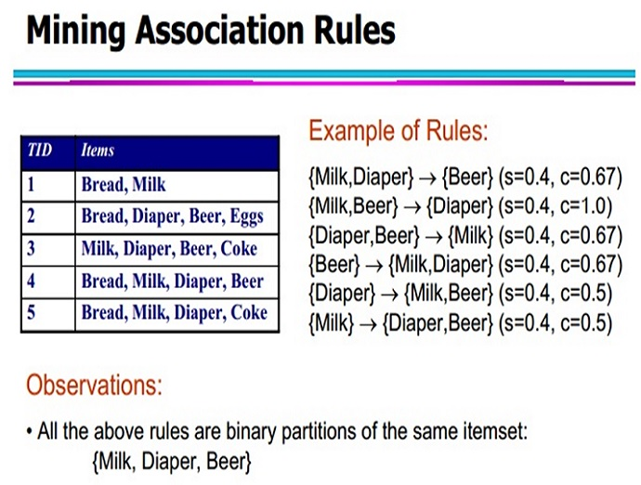
Fig- 3.2.1 Mining Association Rules

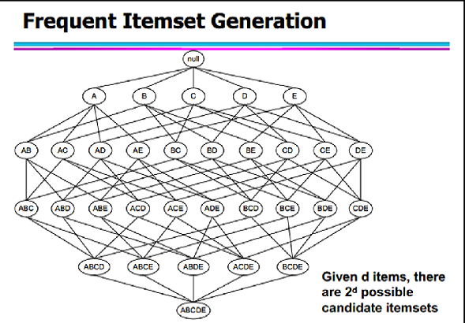
Fig-3.2.2 Frequent Itemset Generation
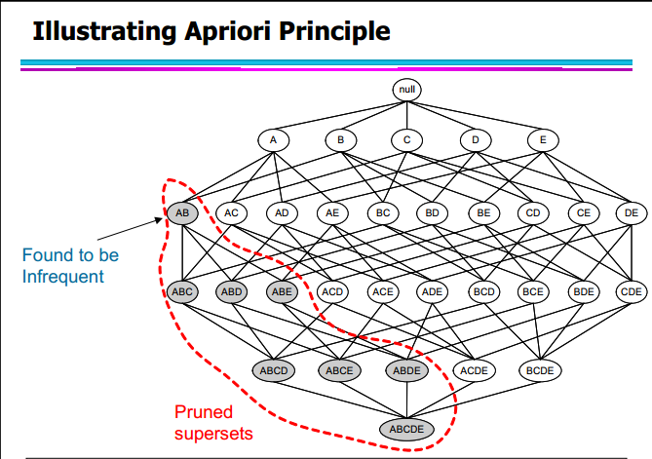
Fig-3.2.3 Illustrating Apriori principle-1
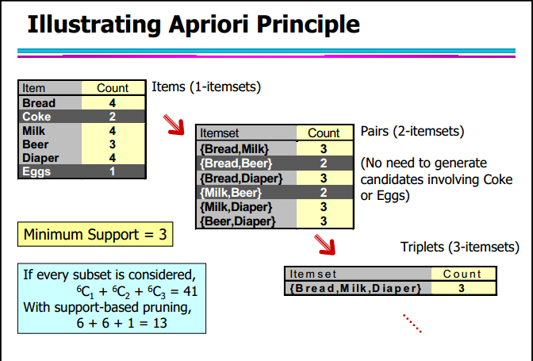
Fig-3.2.4 Illustrating Apriori principle-2
Chapter 4: ALGORITHM PROPOSED
4.1 An improved PNAR based on Dual Confidence and Minimum Correlation
Definition 1: an interesting negative association rule A=>¬B is that in which the following holds [5]:
(1) A ∩ B =φ;
(2) Sup (A)>=minsup, sup (B) >= minsup, sup(A∪¬B) >= minsup;
(3) |Sup (A∪¬B) - sup (A) × sup (¬B)|= |Sup (A∪B) - sup (A) × sup (B)|>= mincorr [4].
NB: [5] It needs to satisfy condition sup (B)>=minsup since we are only interested in frequent itemset in association rules. By the same way we can define conditions of negative association rules forms as ¬A=>B and ¬A=>¬B. If A=>¬B is a negative association rule,
A∪B will be an interesting infrequent itemset. If i is an interesting infrequent itemset, there exists at least one expression, i=A∪ B, which makes one of A=>¬B, ¬A=>B and ¬A=>¬B be interesting negative association rule hold.
4.2 Steps in PNAR:
PNAR Algorithm
As mentioned before, the process of mining both positive and negative association rules can be decomposed into the following three sub problems, in a similar way to mining positive rules only. [4] [9] [11]
1) Generate the set PL of frequent itemsets and the set NL of infrequent itemsets.
2) Extract positive rules of the form A=>B and ¬A=>¬B in PL.
3) Extract negative rules of the forms A=>¬B and ¬A=>B in NL.
Let DB be a transactional database, and ms(minsup), dms(different minimum support) and P_mc(minimum confidence for positive rules), N_mc(minimum confidence for negative rules) given by the user. Our algorithm for extracting both positive and negative association rules with a correlation coefficient measure and pruning strategies is designed as follows:
Algorithm: Positive and Negative Association Rules
PNAR_improved
Input: DB, ms, dms, P_mc, N_mc, mincorr
Output: AR (PAR U NAR)
//Positive and Negative Association Rules
//Generate PL: set of frequent itemsets and NL: set of infrequent itemsets
- PAR←Ø; NAR←Ø; /* Positive and Negative Association Rules*/
- PL←Ø;NL←Ø;
- Scan DB and find L₁ and NL₁ if it exists
- PL←PL U L₁; NL← NL U NL₁ ;
- For(k=2; L_{k-1}!=Ø; k++){
- C_{k} = L_{k-1} |X| L_{k-1} /* The Join Step */
- For each i € C_{k} if any subset of i is not present in L_{k-1} then
- C_{k} = C_{k} – {i} /* Apriori Rule */
- For each i € C_{k}{
- s=sup(i)
- if(s>=ms)then{
- L_{k}← L_{k} U {i}
- PL←PL U L_{k} } /* end if */
- else {
- NL_{k}← NL_{k} U {i}
- NL← NL U NL_{k} }/*end else */
//Generate Positive Association Rules in PL
- For each frequent itemset i in PL
- For each expression A U B = i and A ∩ B = Ø {
- corr_{A,B} = sup(A U B) - sup(A)*sup(B)
- if |corr_{A,B}| >= mincorr { /* only then interesting [13]*/
- if corr_{A,B} > 0 then { /* Produce (A=>B) and (¬A=>¬B) */
- if conf(A=>B) >= P_mc then
- PAR← PAR U {A=>B};
- If sup(¬A=>¬B)>=dms and conf(¬A=>¬B) >= P_mc then
- NAR← NAR U {¬A=>¬B};
- } /* end if of (21) */
- } /* end if of (20) */
- /* end For each of (18) */
//Generate Negative Association Rules in NL
- For each infrequent itemset i in NL
- For each expression A U B = i and A ∩ B = Ø {
- corr_{A,B} = sup(A U B) - sup(A)*sup(B)
- if |corr_{A,B}| >= mincorr {/* only then interesting [13]*/
- if corr_{A,B} < 0 then { /* Produce (¬A=>B) and (A=>¬B) */
- if sup(A=>¬B) >= dms and conf( A=>¬B) >= N_mc then
- NAR←NAR U { A=>¬B };
- if sup(¬A=>B) >= dms and conf(¬ A=>B) >= N_mc then
- NAR←NAR U { ¬A=>B };
- } /*end if of (33)*/
- }/*end if of (32)*/
- }/*end For each of (30)*/
- }/*end For each of (9)*/
- }/*end For of (5)*/
- AR = PAR U NAR
- Return(AR);

PNAR generates not only all positive association rules in PL, but also negative association rules in NL [4]. When mining negative association rules, we adopt a different threshold to improve the usability of the frequent negative itemsets. With a correlation coefficient threshold and pruning strategies, the algorithm can find all interesting as well as valid association rules quickly. An example is given in the following pages.
  - Choosing threshold values
The key element that makes association rule mining practical is the minsup threshold. It is used to prune the search space and to limit the number of frequent itemsets and rules generated [13]. However, using only a single minsup implicitly assumes that all items in the data are of the same nature and/or have similar frequencies in the database [6].
This is often not the case in real-life applications. In many applications, some items appear very frequently in the data, while some other items rarely appear. If the frequencies of items vary a great deal, we will encounter two problems [6] [13]
- If the minsup is set too high, we will not find rules that involve infrequent items or rare items in the data.
- In order to find rules that involve both frequent and infrequent items, we have to set the minsup to a moderately average value.
Care must also be taken to set the dms, P_mc, N_mc to appropriate values such that no important rule goes missing and there is no explosion of the number of rules as well.

Chapter 5: RESULTS OBTAINED
  - Examples of Transactions and Frequent Itemsets
For the convenience of comparison and computations, we conducted our experiments on synthetic dataset to study the behaviours of the algorithm [10]. Let us consider a small transactional database (which was used in the experiment) to analyse the results
TID | Items | TID | Items | TID | Items | TID | Items
1. | A,C,D,F,G,I | 6. | E,G,I,J | 11. | A,B,E,G,J | 16. | B,C,D,F,H,I
2. | B,C,H,J | 7. | B,D,F,G,H | 12. | B,D,F,H,I | 17. | A,C,E,F,H,J
3. | C,D,E,G,I | 8. | B,C,F,J | 13. | B,C,E,F,G,I | 18. | A,B,C,D,E,G
4. | A,B,F,H,J | 9. | B,C,E,I | 14. | A,B,D,H,J | 19. | A,B,C,H,I,J
5. | A,C,D,I | 10. | A,D,F,H,J | 15. | A,C,E,F,G,I | 20. | A,C,D,E,G,I,J
Table-5.1.1 Transactional Database
The Itemset is I = {A,B,C,D,E,F,G,H,I,J} and transactions are listed from TID-1 to TID-20.
We have considered the following thresholds in our experiment.
- Minimum Support (minsup) = 0.2
- Different Minimum Support (dms) = 0.50
- P_Minimum Confidence (P_mc) = 0.70
- N_Minimum Confidence (N_mc) = 1 – P_Minimum Confidence = 0.3
- Minimum Correlation Threshold (mincorr) = 0.1
- Maximum No. of Rules of each type (nRules) = 100
In the following tables L_{k} is denoted as all frequent k- itemset. Given that ms=0.2, all the positive and negative frequent itemsets can then be discovered in Tables (5.1.2-5.1.4) by improved PNAR algorithm. All positive and negative frequent itemsets can then be discovered in Tables (5.1.5-5.1.7) if we adopt different ms=0.50. In Table (5.1.8-5.1.9), we compare Apriori, PNAR and improved PNAR algorithms.
Note: Only a few itemsets and their supports are listed in the tables.
L₁ | Supp | L₁ | Supp | L₁ | Supp | L₁ | Supp | L₁ | Supp
A | 0.60 | C | 0.60 | E | 0.45 | G | 0.45 | I | 0.55
B | 0.60 | D | 0.50 | F | 0.50 | H | 0.45 | J | 0.50
Table-5.1.2 Frequent-1 Itemsets when ms=0.2

L₂ | Supp | L₂ | Supp | L₂ | Supp | L₂ | Supp | L₂ | Supp
AC | 0.70 | CI | 0.80 | ¬AC | 0.40 | B¬C | 0.60 | A¬F | 0.70
AI | 0.60 | HJ | 0.60 | C¬D | 0.60 | A¬B | 0.60 | A¬C | 0.50
Table-5.1.3 Frequent-2 Itemsets when ms=0.2

L₃ | Supp | L₃ | Supp | L₃ | Supp | L₃ | Supp | L₃ | Supp
ACI | 0.25 | CEG | 0.25 | AB¬G | 1.00 | ¬ACF | 0.95 | ¬AGI | 0.95
AHJ | 0.25 | CDG | 0.20 | ¬BCD | 1.00 | ¬AEG | 0.95 | A¬BH | 0.90
Table-5.1.4 Frequent-3 Itemsets when ms=0.2
L1 | Supp | L1 | Supp | L1 | Supp
A | 0.60 | C | 0.60 | I | 0.55
B | 0.60 | D | 0.50 | J | 0.50
Table-5.1.5 Frequent-1 Itemsets when ms=0.5
L₂ | Supp | L₂ | Supp | L₂ | Supp | L₂ | Supp | L₂ | Supp
AC | 0.70 | CI | 0.80 | ¬AC | 0.40 | B¬C | 0.60 | A¬F | 0.70
AI | 0.60 | HJ | 0.60 | C¬D | 0.60 | A¬B | 0.60 | A¬C | 0.50
Table-5.1.6 Frequent-2 Itemsets when ms=0.5
L3 | Supp | L3 | Supp | L3 | Supp
AB¬G | 1.00 | ¬ACF | 0.95 | ¬AGI | 0.95
¬BCD | 1.00 | ¬AEG | 0.95 | A¬BH | 0.90
Table-5.1.7 Frequent-3 Itemsets when ms=0.5
Algorithm | minsup | dms | mc/P_mc | dmc/N_mc | mincorr | L₁ | L₂ | L₃
Apriori | 0.20 |  | 0.70 |  |  | 10 | 30 | 15
PNAR | 0.20 | 0.50 | mc=0.70 |  |  | 10 | 37 | 18
PNAR | 0.20 | 0.50 | mc=0.70 | dmc=0.15 |  | 10 | 36 | 18
PNAR  improved | 0.20 | 0.50 | 0.70 | 0.30 | 0.10 | 10 | 35 | 18
Table-5.1.8 Comparison of all algorithms with frequent positive(L_{k}) itemsets

Algorithm | minsup | dms | mc*/P_mc | dmc/N_mc | mincorr | NL₁ | NL₂ | NL₃
Apriori | 0.20 |  | 0.70
PNAR | 0.20 | 0.50 | mc=0.70 |  |  | 0 | 8 | 17
PNAR | 0.20 | 0.50 | mc=0.70 | dmc=0.15 |  | 0 | 8 | 17
PNAR  improved | 0.20 | 0.50 | 0.70 | 0.30 | 0.10 | 0 | 10 | 26
Table-5.1.9 Comparison of all algorithms with frequent negative(NL_{k}) itemsets
5.2 Rules and Screenshots:
A total of 92 rules of type A=>B and ¬A=>¬B were generated and 101 Rules of type A=>¬B and ¬A=>B were generated when minsup=0.2 using the improved algorithm. A sharp change in the generated rules has been noticed on changing the threshold values up to small extents.
Items A to J are numbered as 1 to 10 in the program. A few of the rules generated are here as follows:
Rule (Support, Confidence, Correlation Factor)

Negative Association rules are represented by Item -A => Item -B, Item -A => Item B, Item A => Item –B. Positive rules are represented by Item A => Item B
Item -1 , Item -8 => Item -10 (100%, 133.3333%, 0.25)
Item -3 , Item -5 , Item -9 => Item -7 (100%, 125%, 0.2)
Item -1 , Item -7 => Item -3 (95%, 126.6667%, 0.2)
Item -1 , Item -9 => Item -3 (95%, 135.7143%, 0.25)
Item -1 , Item -7 => Item -5 (95%, 126.6667%, 0.2)
Item -8 , Item -10 => Item -1 (95%, 135.7143%, 0.25)
Item 5 => Item 7 (35%, 77.7778%, 0.1475)
Item 7 => Item 5 (35%, 77.7778%, 0.1475)
Item 1 , Item 3 => Item 9 (25%, 71.4286%, 0.25)
Item 1 , Item 9 => Item 3 (25%, 83.3333%, 0.25)
Item 1 , Item 8 => Item 10 (25%, 100%, 0.25)
Item 1 , Item 10 => Item 8 (25%, 71.4286%, 0.25)
Item 8 , Item 10 => Item 1 (25%, 83.3333%, 0.25)
Item 3 , Item 4 => Item 9 (25%, 83.3333%, 0.25)

Rule (Support, Confidence, Correlation Factor)

Item 1 => Item -4 , Item -8 (50%, 83.3333%, -0.32)
Item 1 => Item -6 , Item -7 (50%, 83.3333%, -0.35)
Item -1 => Item 6 , Item 8 (50%, 125%, -0.24)
Item 1 => Item -6 , Item -9 (50%, 83.3333%, -0.38)
Item 2 => Item -3 , Item -4 (50%, 83.3333%, -0.38)
Item 3 => Item -2 , Item -4 (50%, 83.3333%, -0.41)
Item 2 => Item -3 , Item -5 (50%, 83.3333%, -0.35)
Item 3 => Item -2 , Item -5 (50%, 83.3333%, -0.41)
Item -6 => Item 1 , Item 2 (85%, 170%, -0.4)
Item -1 => Item 2 , Item 3 (80%, 200%, -0.44)
Item -3 => Item 1 , Item 2 (80%, 200%, -0.44)
Item -4 => Item 1 , Item 2 (80%, 160%, -0.35)
Item -7 => Item 1 , Item 2 (80%, 145.4545%, -0.305)
Item -1 => Item 2 , Item 9 (80%, 200%, -0.44)
Item -9 => Item 1 , Item 2 (80%, 177.7778%, -0.395)

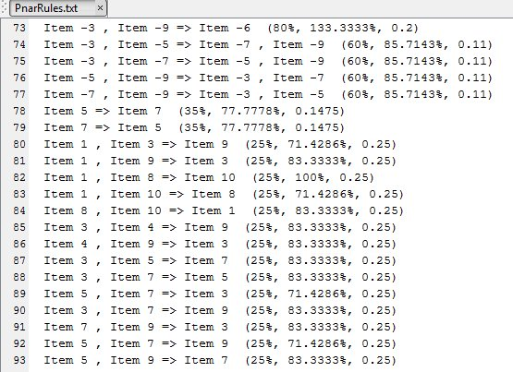
Fig 5.2.1- Screenshot displaying Association Rules in MATLAB
  - Analysis of Results
For a better understanding we have constructed a plot between the correlation threshold (mincorr) and the number of rules generated (N) by the improved PNAR algorithm and we show how N varied with mincorr.
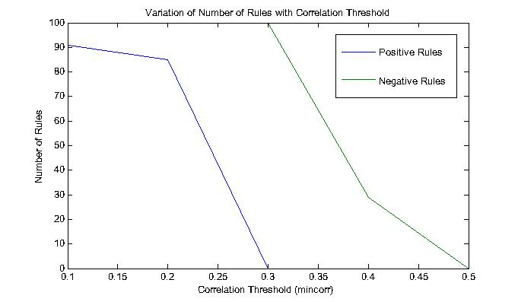
Fig-5.3.1 Variation of the Number of Rules with Correlation threshold

From our experimental computations, we observe that the maximum correlation coefficient for positive rules (of type A=>B and ¬A=>¬B) is 0.25 and the maximum negative correlation coefficient for rules (of type ¬A=>B and A=>¬B) is -0.44. Percentage of rules having correlation coefficient greater than 0.20 is 30.05 % and the percentage of rules having correlation coefficient less than -0.25 is 35.75%. Our objective is to eliminate highly negative correlated rules constituting in this 35.75% as well as to increase the former figure beyond 30.05%. From our experimental analysis, we can identify the rules which have a high negative correlation coefficient and can therefore discard them from our study. Also, we can try to identify those rules which have a high positive correlation coefficient since they are strong positive rules. The range of correlation function is from -1 to +1. Any rule which has a correlation coefficient close to zero (corr → 0) will be redundant because the antecedent and consequent terms will be independent in such a situation. We have also constructed a few other plots describing the variation of the number of generated rules with other threshold values as well.
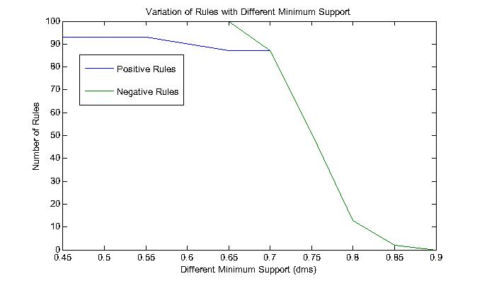
Fig-5.3.2 Variation of the Number of Rules with Different Minimum Support (dms)
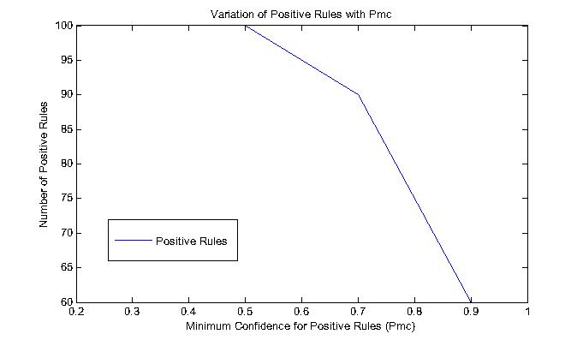
Fig-5.3.3 Variation of the Number of Rules with Minimum Confidence for Positive rules (P_mc)
Number of Negative Rules remains invariant with change in P_mc in our experiment.
We have also constructed a plot between the correlation threshold (mincorr) and the number of rules generated (N) and we show how N varied with mincorr for another dataset containing 60 transactions and the 10 items (A to J) which was listed above.
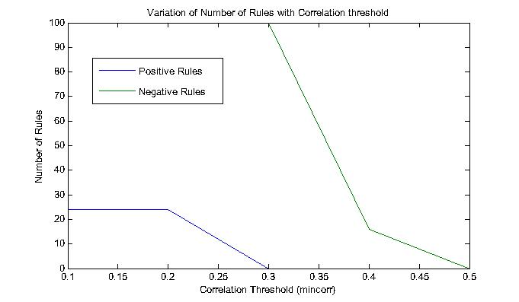
Fig-5.3.4 Variation of the Number of Rules with Correlation threshold for a different dataset
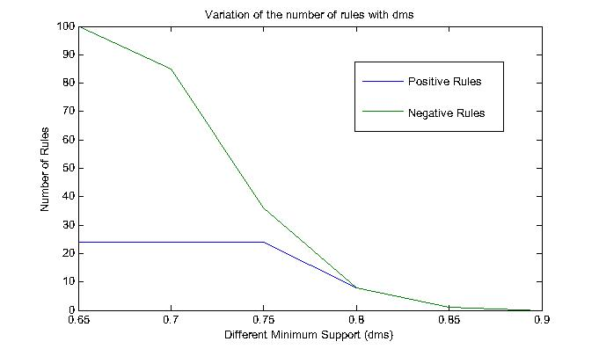
Fig-5.3.5 Variation of the Number of Rules with different minimum support for a different dataset
Chapter 6: APPLICATIONS
6.1 Applications of Association Rule Mining [12]

6.1.1 Market Basket Data Analysis

[12] A typical and widely-used example of association rule mining is market basket analysis. For example, data are collected using bar-code scanners in supermarkets. Such ‘market basket’ databases consist of a large number of transaction records. Each record lists all items bought by a customer on a single purchase transaction. Managers would be interested to know if certain groups of items are consistently purchased together. They could use this data for adjusting store layouts (placing items optimally with respect to each other) for effective sale & purchase. For example, if a supermarket database has 100,000 point-of-sale transactions, out of which 2,000 include both items A and B and 800 of these include item C, the association rule "If A and B are purchased then C is purchased on the same trip" has a support of 800 transactions (alternatively 0.8% = 800/100,000) and a confidence of 40% (=800/2,000)
If A is “purchased pizza” and B is “purchased soda” then Support = P (A U B) = ¼ Confidence = P (B | A) = ½.

Customer | Item Purchased | Item Purchased
1. | Pizza | Beer
2. | Salad | Soda
3. | Pizza | Soda
4. | Salad | Tea
Fig-6.1.1.1 Example of Market Basket Data Analysis
In particular, commercial organizations are interested in discovering “association rules” that identify patterns of purchases, such that the presence of one item in a basket will imply the presence of one or more additional items

6.1.2 Web Personalization
Personalization is the use of customer information for delivering a customized solution to that customer thus satisfying personal needs [8]. In the e-commerce environment the available choices for the visiting customers are more. The search cost and time increase due to this overload. Personalization can aid the customer in decision making process. Personalization can also communicate appropriate messages to the right customers on the basis of customer profiles. Typical stages in personalization are discussed by Murthi & Sarkar [8]. Common way to incorporate personalization in firm’s interaction with customers is through the use of recommender system.

6.1.3 Recommender Systems

Customers like to have a recommender system by which customer can see the feedback from other users who already purchased the products. E-commerce makes use of recommender system to not only show feedback from other users but also suggest interesting and useful products to customers. Geyer et al [7] describes a recommender system that uses
association rules derived from past purchases, for making recommendations to new anonymous customers. Diverse recommendation systems are proposed for different business which guides the customers to find products they would like to purchase. Most of them are based on either content filtering or collaborative filtering. Content based filtering (CBF) approach recommends products to target customers according to the preferences of their neighbours. The collaborative filtering (CF) approach recommends products to object customers based on their past preferences. Set of association rules are mined from customer requirements database using Apriori algorithm and then he apply CBA-CB algorithm to produce best rules out of whole set of rules.
6.1.4 Cross Selling Analysis
The association rule mining is a powerful tool to realize cross selling. Cross selling is a marketing strategy to sell a new product or service to the customer who already used the products of the same enterprise. To introduce a new product or service to a new customer and an old customer, the old customer is more likely to accept it and the success rate is higher.
Cross selling is a marketing method which can improve customer value, for the more the relations between the enterprise and the customer, the more dependent the customer will be on the enterprise, and the higher the loyalty will be. Xiao-li Yin [14]
discusses how the banks analyze the association relations between the deal activities and other properties like customer age, gender, education, occupation, etc, and can get the result which bank services or financial products the customer will be interested in.
6.1.5 Purchasing and traveling behaviour of customers
In e-commerce environment finding association rules between purchasing items is very important. There are many algorithms devised in this field. Path traversal pattern mining is the technique that finds most of the navigation behaviours of customers in the e-commerce environment. This information can be used to improve the website design and performance.
Navigational suggestions can also be suggested to customers using this information. Many works are carried out in this field.

CONCLUSION AND FUTURE WORK
We have made an improvement to the traditional PNAR algorithm [4] for efficiently mining positive and negative association rules in transactional databases. We have adopted the dual confidence and correlation threshold approach where either confidence values sum to give unity. Therefore weight can be differently assigned to each type of rules in the process. Our approach is novel and different from existing research. We have designed pruning strategies for reducing the search space and improving the usability of mining rules, and have used the correlation coefficient to judge which form of association rule should be mined.
We have used the correlation threshold to monitor the interestingness of the rules mined. Our objective is to find rules which have a high positive correlation coefficient value i.e which are highly positively correlated and eliminate rules which are highly negatively correlated.
In our experiment, for a particular dataset, our algorithm generates 30% highly positive rules which is our primary concern and 35.75% highly negative rules which can be eliminated from the set.
This paper gives overall review for association rules generation and positive negative rules finding from large data. A new algorithm is presented to generate all positive and negative class association rules using correlation threshold and dual confidence approach and to build an accurate and non-contradictory set of rules. The scheme has several features:
- Its classification is performed based on positive and negative class association rules, which leads to better overall classification accuracy.
- It prunes contradictory positive and negative class association rules effectively based on correlation between itemsets.
This proposed method expected that the algorithm would be highly effective at classification and has better average classification accuracy and efficiency. In future, this algorithm is performed for various large datasets and measurements will be taken for proof effectiveness of proposed algorithm as well as other factors, techniques and parameters can be taken into consideration namely Hash-based technique [1], F-P growth tree analysis [1], chi square correlation analysis [1], Bayesian approach [1] and Kulczynski measures [1] which will help generate more interesting association rules. The primary focus of research in this particular area has to deal with the interestingness and validity of the rules generated.

REFERENCES
- “DATA MINING Concepts and Techniques (2011)” Jiawei Han| Micheline Kamber| Jian Pei,
pp 243 – 317
- R. Agrawal, T. IMIELINSKI, and A. SWAMI, “Mining association rules between sets of items in massive databases,” In Proc. of the 1993 ACM SIGMOD International Conference on Management of Data, ACM, Washington D.C., 1993, pp. 207-216.
- R. Agrawal, R. Srikant, “Fast Algorithms for Mining Association Rules,” In Proc. of the 20th Int. Conf. on Very Large Databases(VLDB’94), Santiago, Chile, 1994, pp. 487-499.
- Honglei Zhu, Zhigang Xu, “An Effective Algorithm for Mining Positive and Negative Association Rules,” In Proc. Of the 2008 International Conference on Computer Science and Software Engineering, 2008, pp. 455-458.
- Ruchi Bhargava, Prof. Shrikant Lade, “Effective Positive Negative Association Rule Mining Using Improved Frequent Pattern,” In Proc. of the International Journal of Modern Engineering Research (IJMER), 2013, pp. 1256-1262.
- R. Uday Kiran and P. Krishna Reddy, “An Improved Multiple Minimum Support Based
Approach to Mine Rare Association Rules”, In Proc. of IEEE International Conference on Data Management, 2009.
- Liu Guo-rong， Zhang Xi-zheng, “Collaborative Filtering Based Recommendation system for Product bundling”, Proceeding of ICMSE’06, Lille, France, pp.251 -254, 2006.
- Murthi B P S, Sarkar S 2003.”The role of management sciences in research on personalization. Manage. Sci 49:1344-1362
- X. Wu, C. Zhang, and S. Zhang, “Efficient Mining of Both Positive and Negative Association Rules,” ACM Transactions on Information Systems, Vol. 22, No. 3, 2004, pp. 381–405.
- M. CHEN, J. HAN, and P. YU, “Data mining: An overview from a database perspective,” IEEE Transactions on Knowledge and Data Engineering, Vol. 8, No. 6, 1996, pp. 866-883.
- X. Dong, S. Wang, H. Song, and Y. Lu, “Study on Negative Association Rules,” Transactions of Beijing Institute of Technology, Vol. 24, No. 11, 2004, pp. 978-981.
- S. Brin, R. Motwani, and C. Silverstenin, “Beyond market baskets: Generalizing association rules to correlations,” In Proc. of the 1997 ACM SIGMOD International Conference on Management of
Data, ACM, Tucson, Arizona, 1997, pp. 265–276.
- Mojdeh Jalali-Heravi, Osmar R. Zaïane, “A Study on Interestingness Measures for Associative Classifiers,” TProceedings of the 2010 ACM Symposium on Applied Computing,2010,pp,
T1039-1046.
- Xiao-li Yin and Xu-sheng Fang," Data Mining Technology Application in Bank CRM", Economic Research Guide, 2009, pp. 112-113.
APPENDIX - A
Theorem 3.1
- Proof (1): |Sup(¬A=>B) – Sup(¬A)Sup(B)|
= |Sup(B) – Sup(AUB) – (1-Sup(A))Sup(B)|
= |Sup(B) – Sup(AUB) – Sup(B)+Sup(A)Sup(B)|
= | – Sup(AUB)+Sup(A)Sup(B)|
= | – (Sup(AUB) - Sup(A)Sup(B))|
= |(Sup(AUB) - Sup(A)Sup(B)|
- Proof(2): |Sup(A=>¬B) – Sup(A)Sup(¬B)|
= |Sup(A) – Sup(AUB) – Sup(A)(1-Sup(B))|
= |Sup(A) – Sup(AUB) – Sup(A) + Sup(A)Sup(B)|
= | – Sup(AUB)+Sup(A)Sup(B)|
= | – (Sup(AUB) - Sup(A)Sup(B))|
= |(Sup(AUB) - Sup(A)Sup(B)|
- Proof(3): |Sup(¬A=>¬B) – Sup(¬A)Sup(¬B)|
= |1 – Sup(A) – Sup(B) + Sup(AUB) – (1 – Sup(A))(1 – Sup(B))|
= |1 – Sup(A) – Sup(B) + Sup(AUB) – 1 + Sup(B) + Sup(A) – Sup(A)Sup(B)|
= |(Sup(AUB) - Sup(A)Sup(B)|

INDEX
Sl.No. Keyword, (Page(s))
- itemset, (6, 9, 11-18, 21 ,24, 26, 28, 29, 30,37)
- frequent itemsets, (6, 11, 12, 14, 15-17, 21, 24, 26, 28)
- infrequent itemsets, (17, 24)
- data mining, (6, 11, 12, 13, 38)
- association rules, (6, 10, 11, 12-22, 24-26, 31, 35-38)
- association rule mining, (1-3, 5, 6, 12-18, 26, 35, 36)
- positive rules, (10, 11, 24, 31, 32, 33, 37)
- negative rules, (11, 17, 19, 24, 33, 37)
- support, (6, 10, 11, 14, 15-19, 21, 24, 28, 31,33-35, 38)
- minmum support, (10, 11, 14-16, 19, 21, 24, 28, 33, 34, 38)
- confidence, (1-3, 5, 6, 10-12, 14-19, 21, 24, 28, 31, 33, 35, 37)
- minimum confidence, (10, 11, 19, 21, 24, 28, 33)
- dual confidence, (1-3, 5, 6, 12, 19, 24, 37)
- different minimum support, (10, 11, 19, 24, 28, 33, 34)
- correlation threshold, (1-3, 5, 10, 11, 12, 19, 28, 32, 34, 37)
- correlation coefficient, (11, 12, 18, 19, 24, 26, 32, 37)
- transactional database, (28)
- minsup, (11, 18, 24, 26, 27, 28, 30)
- minconf, (11, 18, 19)
- mincorr, (11, 19, 20, 24, 25, 26, 28, 30, 32, 34)
- P_mc, (10, 11, 24, 25, 27, 28, 30, 33)
- N_mc, (11, 24, 26, 27, 28, 30)
- dms, (10, 11, 19, 24, 25-28, 30, 33)

